**A robust, generalizable model for canopy detection from generic LiDAR in the contiguous United States**

S. Jones1[1]*, R. El Kadiri1[2] and H.G. Momm1b

1Department of Geosciences, Middle Tennessee State University, Murfreesboro, Tennessee

*corresponding author: rj3h@mtmail.mtsu.edu

**Abstract:**

LiDAR point clouds have long been used to perform land cover classification. In particular, LiDAR has been extremely helpful for developing canopy detection models, which differentiate tree canopies from other types of landcover. However, canopy detection from LiDAR requires investigators to either provide data to train the model, use vendor classification codes that vary in quality, or rely on rough heuristics to estimate canopy cover. By analyzing land cover signatures in 10 watersheds across the contiguous United States that are physiographically and ecologically distinct and have LiDAR coverage that has been collected during various seasons and is of variable quality, we have developed a pretrained canopy detection model that can identify canopy cover with high accuracy (98.5%, Cohen’s κ = 0.958) in watersheds that the model has not yet encountered and with LiDAR of variable quality, allowing general canopy detection with no need for parameter tweaking or other user input. This work also establishes a framework for the design of generalized models that perform more granular classification using LiDAR data.

**Keywords:**

Canopy; general; LiDAR; machine learning; point cloud; land cover; classification

**One Sentence Summary:**

Tree canopy signatures from LiDAR are consistent across a diverse assortment of watersheds and LiDAR missions, and thus tree canopy using a general, pretrained model is possible.

# Introduction

* Uses of LiDAR point clouds
* Existing canopy and land cover detection/classification methods
  + Closed source (ENVI, Arc, etc.)
    - Do these use vendor class codes? Naïve height model proxy?
  + Detection from point cloud vs. raster
  + Detection from aerial imagery (including photogrammetry)
  + Make mention of current model performance (quality, number of classes, etc.)
* Need for generalized model

# Methods

## Model Design

LiDAR data in LAS format covering 10 watersheds across the contiguous United States were downloaded. The individual LAS files were then mosaiced together on a per-watershed basis using LAStools, and a suite of tools, including WhiteboxTools, laspy, GDAL, Orfeo, scipy and custom Python tools were used to process the LAS files into various raster products. These derived raster products were manually inspected along with aerial imagery to create training and validation data for each of the 10 watersheds (Table 3). 80% of the manually classified pixels were used as training data for a decision tree machine learning algorithm. A decision tree scheme was chosen over other machine learning algorithms because its output is easily interpretable, does not require normalized input and can be translated into a set of if-else statements, allowing the model to be distributed without a need for specific software to run the model.

The resultant decision tree was then validated against the remaining 20% of the data from the 7 trained watersheds, as well as 100% of the data from the 3 naïve watersheds. Input data was inversely weighted to amount of data for each watershed; that is, all watersheds were weighted equally regardless of differences in the number of contributing pixels. Raw accuracy scores as well as Cohen’s κ statistics were calculated individually for each watershed in this study.

## Derived Raster Products

A summary of the raster products generated from the collected LiDAR data is given in Table 4. The details of each product are given in subsequent sections. Because the classification model described in this paper is intended to be general, no data products generated made use of vendor-supplied classification codes. For rasters created by interpolating LiDAR point cloud values, a triangular irregular network (TIN) algorithm was used. All rasters created used a pixel size of 1m x 1m, regardless of source LiDAR point density.

### Digital surface model

A digital surface model (DSM) is created by interpolating the height values from only the first returns in a LiDAR point cloud. Thus, the DSM represents the elevation of the earth’s surface including above-ground structures such as buildings and tree canopies.

Though the DSM was used to generate other data products included in the model, the DSM itself was excluded as input to the classification model. This was done because non-normalized elevations have little to no predictive power for landcover type.

### Digital elevation model

A digital elevation model (DEM) is similar to a DSM but is created by interpolating the height values from only the last (rather than first) returns in a LiDAR point cloud. Thus, the DEM represents the elevation of the earth’s surface excluding some above-ground structures tree canopies. Some definitions of the DEM also require removal of built structures, but because this study did not utilize vendor-supplied classification codes, buildings could not be removed from the DEM directly, and so our generated DEM products do include built structures.

The DEM was excluded as direct input to the classification model for the same reasons that the DSM was excluded.

### Digital height model

A digital height model (DHM), sometimes referred to as a normalized digital surface model (nDSM) or height-above-ground model, is the result of the raster subtraction of the DEM from the DSM. The DHM represents the distance between the ground and any overhead structures, such as tree canopies or powerlines. Because building edges often produce multiple returns, building edges frequently appear in DHMs. The DHM is often used as a rough proxy for canopy height because its signature is dominated by tree, while building edges, powerlines, and other anthropogenic structures are minor contributors.

The DHM was excluded as direct input to the classification model but a modified version of it, described in the next section, was included.

### Filtered digital height model

Though the DHM roughly represents canopy height, the anthropogenic structures such as building edges and powerlines contribute significantly to the DHM in urban areas. Because of this, many investigators have proposed methods to distinguish the signature of trees from built structures through various means (cite e.g., the paper with the linear feature filter). Though many existing methods exist to filter built structures from a DHM, we elected to use a simple density filter due to its ease of implementation, quick runtime and high selectivity for canopy signals. The filter works such that, for every target pixel in the DHM, a 3 by 3 window is extracted. If over 30% of the pixels (3 or more) in the window are nonzero, then the target pixel’s value is retained. Otherwise, the target pixel is set to 0. This filter removes linear features, such as building edges and powerlines, while retaining more rounded features such as tree canopies. The result is a filtered DHM (fDHM).

Though the unfiltered DHM was excluded as a direct input to the model to limit false classification of building edges as trees, the filtered DHM was included as direct input.

### Intensity raster

A raster representing the average return intensity at each pixel was created by interpolating LiDAR return intensity values. Because intensity values are not normalized and are a function of sensor type, pulse strength, and aircraft altitude in addition to the land cover type being sensed, the intensity rasters were not used as classification model input. However, they are usefully qualitatively and were used to aid manual land cover classification.

### Return raster

A raster representing the average number of returns in a pixel was created by interpolating the return number of the last return for each LiDAR pulse. Like the intensity raster, the number of returns is a function of variables beyond just the land cover type and so was excluded from being used as classification model input, but it was used to aid manual land cover classification.

### Slope rasters

For each elevation-based model (DSM, DEM, DMM, fDHM) a slope raster was created representing the maximum slope between a given pixel and its 8 neighbors. The slope is given in degrees. These products were included as direct input to the classification model.

### Roughness rasters

A “roughness” raster was created for each elevation-based model (DSM, DEM, DMM, fDHM) by applying a filter that returns the maximum difference in values between a target pixel and its 8 neighbors. These products were included as direct input to the classification model.

### Laplacian filtered rasters

Laplacian filters are commonly used to emphasize areas of rapid change in imagery. This emphasis on rapid change has led to widespread use of the Laplace filter for edge detection, but a Laplace-filtered image can be thought of more generally as a textural derivative of the parent image. Laplacian filters can be expressed as a convolution operation, and the convolution matrix used in this study is $\left[\begin{matrix}-1 & -1 & -1 \\ -1 & 8 & -1 \\ -1 & -1 & -1\end{matrix}\right]$. A Laplacian-filtered raster was created for each elevation-based model (DSM, DEM, DMM, fDHM), and these products were included as direct input to the classification model.

### Haralick textures

Haralick textures, or Haralick features, is the name given to a set of indicators derived from a matrix describing frequency of occurrence of specific value-pairs within subsets of an image. This frequency matrix is called the gray level co-occurrence matrix (GLCM). These derived features are referred to as textures because they tend to quantify the relationships between a given pixel and its neighbors.

From the DHM, we generated 8 Haralick textures: energy, entropy, correlation, inverse difference moment, inertia, cluster shade, cluster prominence and Haralick correlation. However, Haralick textures were ultimately excluded as input to the classification model due to the computational resources required and low boost in model performance compared to models that excluded the textures.

## Study Areas

The 10 areas of interest selected for this study were chosen for their diverse geomorphological, anthropogenic and ecological signatures as well as availability of LiDAR data. Seven of these study areas were selected to train the model (“trained” watersheds), which was validated against the three remaining watersheds (“naïve” watersheds). Characteristics each watershed can be found in Table 1, and an overview of each study area is given in subsequent sections. Characteristics of LiDAR data used to generate data products for each watershed can be found in Table 2.

### Trained Watersheds

The following watersheds were used to train the classification model. 80% of the manually classified pixels from these watersheds were used for training, with the remaining reserved for validation.

#### 010500021301 – Penobscot, ME

Branch Lake watershed (USGS hydrologic unit code: 010500021301) is located approximately 10 miles to the northeast of the coastal town of Penobscot, Maine, and drains to the eponymous Branch Lake. The watershed has a total area of 80.0 square kilometers. The majority of the watershed consists of coniferous forest and open water. Limited agricultural land, open fields and exposed rock are present as well. Overall development in the watershed is low. Relief within the watershed is moderate. Approximately 10.4 square kilometers, or 13.0%, of the watershed was manually classified. The LiDAR data utilized in this study for the watershed was collected between 4/19/2015 and 5/12/2015 with a nominal pulse spacing of 0.70m.

#### 030902040303 – Naples, FL

Strand State Preserve watershed (USGS hydrologic unit code: 030902040303) is located approximately 20 miles to the east of the town of Naples in southwestern Florida. The watershed is named for the Fakahatchee Strand State Preserve, a Florida State Park. The watershed has a total area of 74.7 square kilometers. The watershed is dominated by herbaceous forest, shrubs and wetlands. There is very little development within the watershed. Relief within the watershed is very limited. Approximately 8.1 square kilometers, or 10.8%, of the watershed was manually classified. The LiDAR data utilized in this study for the watershed was collected between 6/12/2007 and 3/8/2008 with a nominal pulse spacing of 0.67m.

#### 0070801050901 – Ames, IA

Walnut Creek watershed (USGS hydrologic unit code: 0070801050901) is located approximately 5 miles to the south of the city of Ames, Iowa. The watershed has a total area of 50.7 square kilometers. The watershed is dominated by agricultural land, with sporadic deciduous tree clusters and riparian buffers. Development is limited to sporadic housing and connecting roads. Relief within the watershed is very limited. Approximately 8.8 square kilometers, or 17.3%, of the watershed was manually classified. The LiDAR data utilized in this study for the watershed was collected of a great length of time: between 4/7/2007 and 5/27/2010. The collected lidar has a nominal pulse spacing of 0.88m.

#### 080102040304 – Trenton, TN

North Fork Forked Deer River Middle watershed (USGS hydrologic unit code: 080102040304) partially encompasses the town of Trenton in western Tennessee. The watershed has a total area of 161.1 square kilometers. Land cover in the watershed consists primarily of agricultural fields and thick deciduous-dominated riparian buffers. There are sporadic townships throughout the watershed. Relief within the watershed is modest. Approximately 10.3 square kilometers, or 6.4%, of the watershed was manually classified. The LiDAR data utilized in this study for the watershed was collected between 12/2/2011 and 1/4/2012 with a nominal pulse spacing of 0.70m.

#### 130202090102 – Datil, NM

Ox Spring Canyon watershed (USGS hydrologic unit code: 130202090102) is located approximately 10 miles north of the town of Datil, New Mexico. The watershed drains a portion of the northern face of Madre Mountain, part of the Datil mountain range. The watershed has a total area of 66.1 square kilometers. Land cover in the watershed is a mix of sand and sandy loam, including dry streambeds, and sparse, shrubby ligneous cover at lower elevations and somewhat denser mixed deciduous and coniferous forest at higher elevations. During the winter, snow may be present at higher elevations. Development in the watershed is nonexistent apart from occasional dirt roads. Relief within the watershed is significant as the watershed encompasses an area that includes mountain peaks at its head and flat scrubland near its terminal point. Approximately 7.7 square kilometers, or 11.6%, of the watershed was manually classified. The LiDAR data utilized in this study for the watershed was collected between 11/2/2017 and 2/8/2018 with a nominal pulse spacing of 0.71m.

#### 140801040103 – Telluride, CO

Mineral Creek watershed (USGS hydrologic unit code: 140801040103) is located approximately 5 miles south of the town of Telluride, Colorado. The watershed is situated within the Rock Mountains and has a total area of 138.6 square kilometers. Land cover in the watershed is diverse and consists of bare rock, grass fields, alluvial deposits, melt-fed lakes and mixed coniferous-deciduous forest. Some amount of snow and ice is typically present perennially, though snow cover can be ubiquitous during the winter. Development in the watershed is limited to footpaths. Relief within the watershed is significant. Approximately 13.2 square kilometers, or 9.6%, of the watershed was manually classified. The LiDAR data utilized in this study for the watershed was collected between 9/6/2017 and 10/24/2017 with a nominal pulse spacing of 0.35m.

#### 180500020905 – San Francisco, CA

Lobos Creek-Frontal San Francisco Bay Estuaries watershed (USGS hydrologic unit code: 180500020905) encompasses part of the city of San Francisco, California. The watershed has a total area of 25.3 square kilometers. Land cover in the watershed largely consists of high-density urban development, including some high-rise buildings. However, a significant amount of plant cover is present as the watershed encompasses The Presidio and part of Golden Gate Park, two large urban parks, in addition to numerous smaller green spaces. A significant number of individual trees are also present along streets throughout the watershed. Thus, herbaceous and woody plant cover comprise an appreciable portion of the land cover in the watershed. San Francisco is a famously hilly city, and relief within the watershed is appreciable though moderate compared to the drastic relief seen in some of the other watersheds included in this study. Approximately 1.3 square kilometers, or 5.1%, of the watershed was manually classified. The LiDAR data utilized in this study for the watershed was collected between 4/23/2010 and 7/14/2010 with a nominal pulse spacing of 0.6m.

### Naïve Watersheds

The following watersheds were used for model validation only – no data from these watersheds were used for model training.

#### 080902030201 – New Orleans, LA

Morrison Canal watershed (USGS hydrologic unit code: 080902030201) is encompasses part of the city of New Orleans, Louisiana. The has a total area of 61.2 square kilometers. Land cover in the watershed consists of medium density urban development, industrial yards, mowed fields, wetlands and open water. Limited agglomerations of trees are also present. Relief within the watershed is minimal. Approximately 4.0 square kilometers, or 6.6%, of the watershed was manually classified. The LiDAR data utilized in this study for the watershed was collected between 1/23/2017 and 4/24/2017 with a nominal pulse spacing of 0.70m.

#### 100301011309 – Helena, MT

Last Chance Gulch watershed (USGS hydrologic unit code: 100301011309) encompasses part of the city of Helena, Montana. The watershed has a total area of 55.5 square kilometers. Though a portion of the watershed is within the city limits of Helena and thus has land use typical of a small American city, most of the watershed is within a rugged, undeveloped mountain drainage to the southwest. Land cover in this drainage consists of open grassy areas punctuated by sparse shrub cover on south-facing slopes and dense mixed coniferous-deciduous tree cover on northerly slopes. Relief within the watershed is significant. Approximately 3.2 square kilometers, or 5.8%, of the watershed was manually classified. The LiDAR data utilized in this study for the watershed was collected between 5/8/2012 and 5/9/2012 with a nominal pulse spacing of 1.46m.

#### 102901110304 – Freeburg, MO

Loose Creek-Maries River watershed (USGS hydrologic unit code: 102901110304) encompasses part of the town of Freeburg, Missouri. The watershed has a total area of 77.8 square kilometers. The watershed’s land cover is dominated by agricultural land use and open fields punctuated by relatively large stands of deciduous trees. Sporadic rural development is also present. Relief within the watershed is moderate. Approximately 6.1 square kilometers, or 6.8%, of the watershed was manually classified. The LiDAR data utilized in this study for the watershed was collected between 4/14/2010 and 5/7/2010 with a nominal pulse spacing of 1.33m.

# Results and Discussion

* High accuracy of model, including in naïve areas
* Limitations of making a general model: cannot include intensity, return number, some textures
* Uses for model: canopy models with no fiddling with numbers, no matter where or the quality of data (within reason)
  + Talk about limitations, including the fact that case fir generalizability can be made stronger with more study areas
* Possibility of extending model in future to do more specific classification

# Conclusions

* Recapitulation

# Data and Materials Availability

All code used in the analysis for this paper is publicly available at <https://github.com/rsjones94/riparian-id>. The LiDAR and manual landcover classification data is available upon request.

# Tables and Figures

Table 1. Information related to each study area used to train or validate the model.

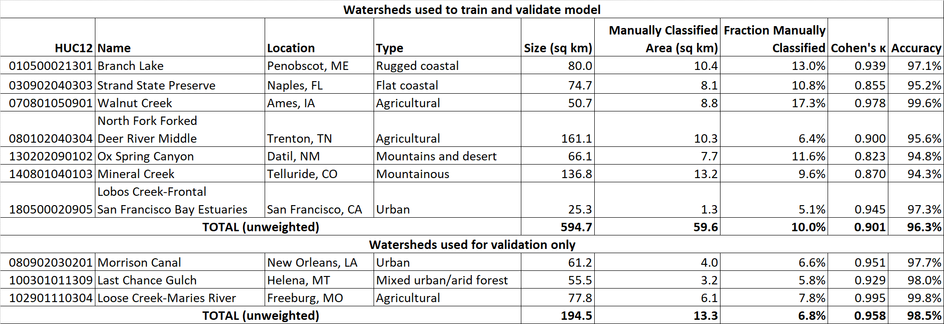

Table 2. Information related to LiDAR characteristics for each study area.

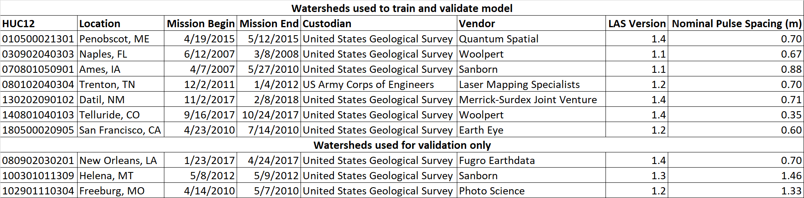

Table 3. Training and validation data classification scheme used in this study.

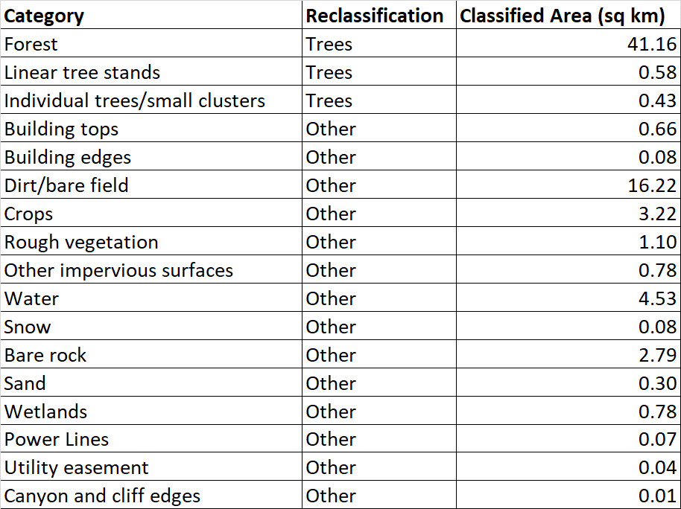

Table 4. Summary of derived raster products used in the model.

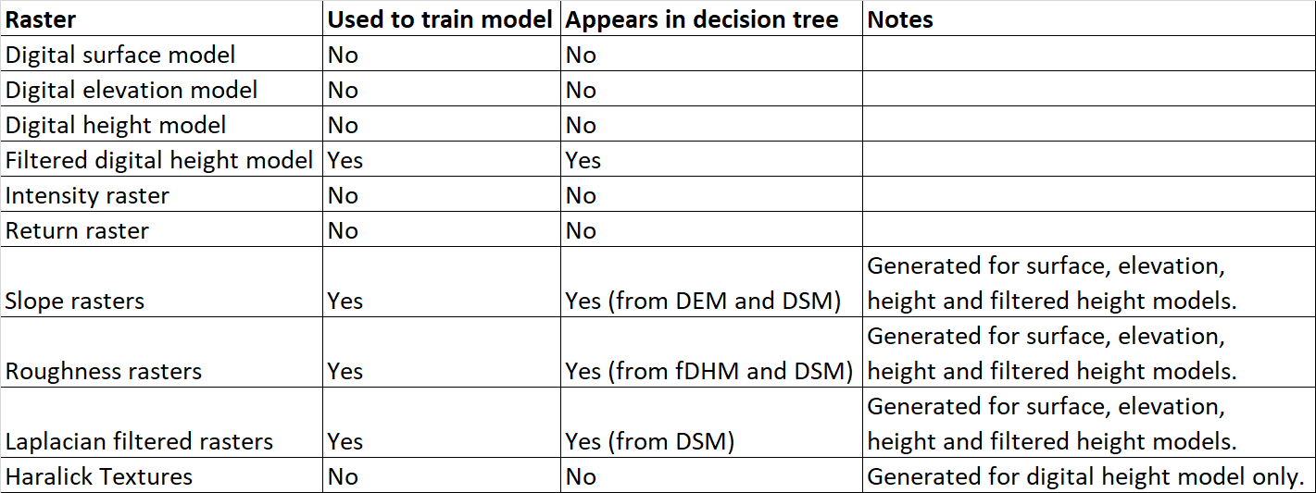

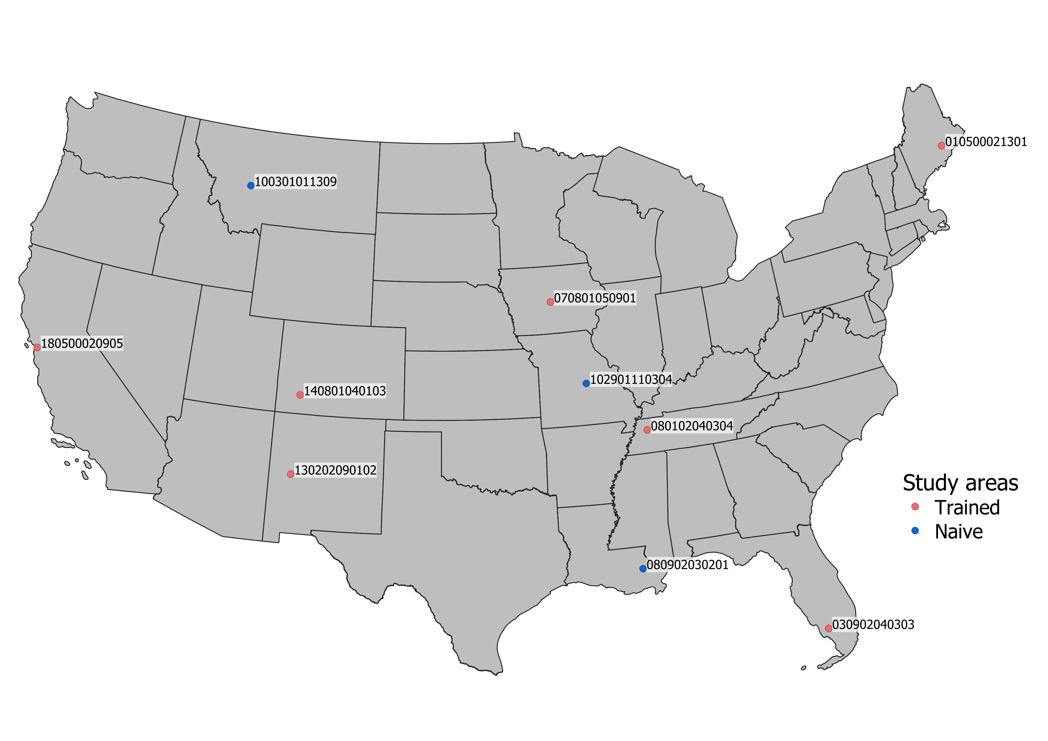

Figure 1. Distribution of watersheds analyzed in this study.

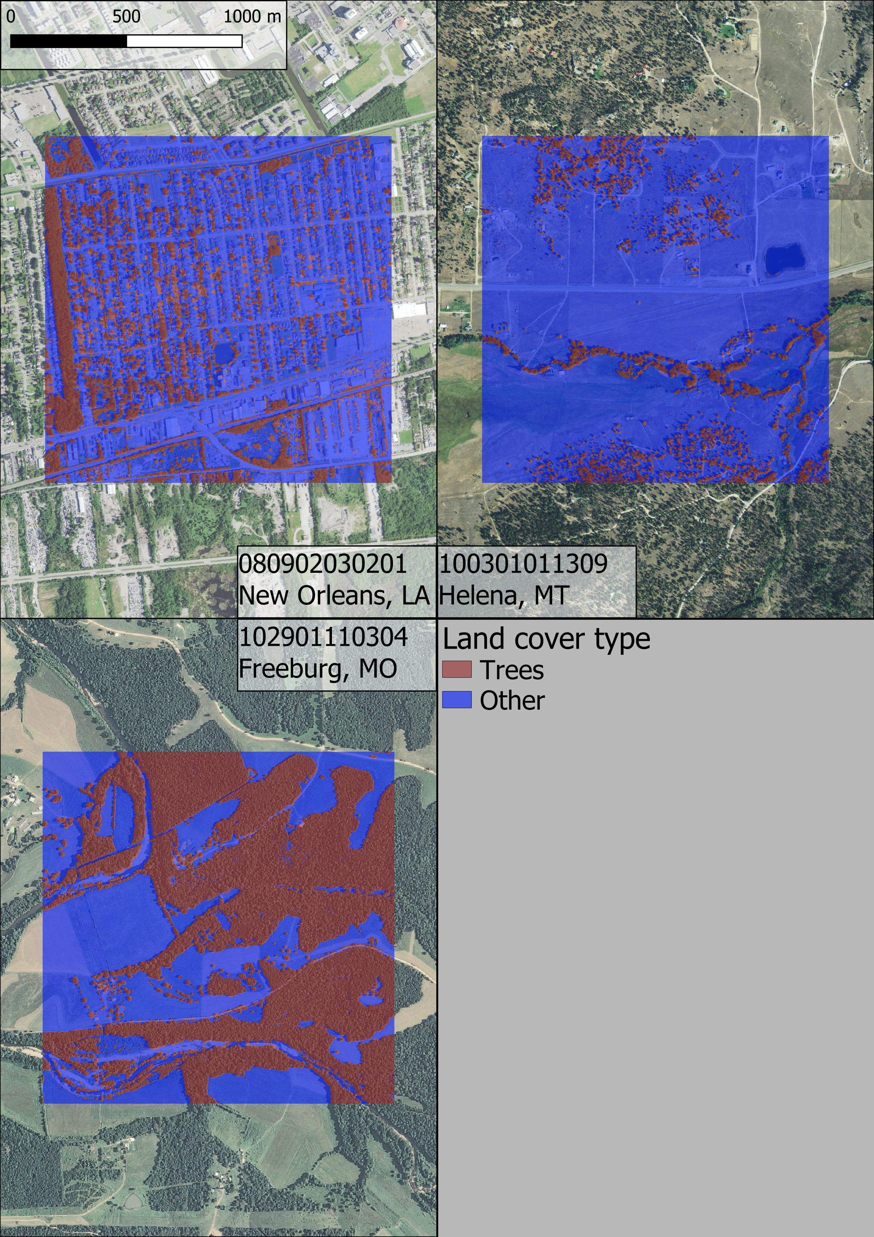

Figure 2. Sample classifications for three of the naïve study areas. Note that the orthoimagery for the New Orleans watershed is not perfectly contemporaneous with the LiDAR input; some trees in the study area were removed between LiDAR and orthoimagery data collection.



Figure 3. Decision tree of the final model. fidhr = filtered digital height model roughness. dsmro = digital surface model roughness. dsmlp = laplace filter of digital surface model. demsl = slope of digital elevation model. dsmsl = slope of digital surface model.

# Acknowledgements

We give our thanks to Connor Reed for his assistance with the creation of our manually classified land cover dataset.

# Funding

This work was supported by the Natural Resources Conservation Service (agreement number NR194741XXXXC005).

# References

Potential works:

* Weinstein, B.G.; Marconi, S.; Bohlman, S.; Zare, A.; White, E. Individual Tree-Crown Detection in RGB Imagery Using Semi-Supervised Deep Learning Neural Networks. Remote Sens. 2019, 11, 1309 **AND** Geographic Generalization in Airborne RGB Deep Learning Tree Detection Ben Weinstein, Sergio Marconi, Stephanie Bohlman, Alina Zare, Ethan P White bioRxiv 790071; doi: <https://doi.org/10.1101/790071>
  + Related to <https://github.com/weecology/DeepForest>. Covers a generalizable RGB-based model for crown-detection. Essentially our work, except imagery based and goes a step further (detecting crowns). Maybe we can implement crown detection?
* <https://pypi.org/project/forestutils/>
  + Tree extraction directly from point clouds. I believe it needs full color point clouds, which come from either photogrammetry or full-color (i.e., expensive) LiDAR scans
* A Segmentation Method for Tree Crown Detection and Modelling from LiDAR Measurements - <https://link.springer.com/chapter/10.1007/978-3-642-31149-9_7>
  + 2012 paper on the inverted watershed (raster-based) method of crown detection
* Trends in Automatic Individual Tree Crown Detection and Delineation—Evolution of LiDAR Data
* <https://www.researchgate.net/publication/259128823_High-resolution_tree_canopy_mapping_for_New_York_City_using_LIDAR_and_object-based_image_analysis>]
* Characterizing urban surface cover and structure with airborne lidar technology
  + Contains schematic for image filter that remove linear structures (building edge detection)
* The Comparison of Different Methods of Texture Analysis for Their Efficacy for Land Use Classification in Satellite Imagery

1. Responsible for design, implementation and testing of model, collection and processing of data, and drafting of manuscript.
2. Responsible for supervision of model design, manuscript drafting and revision.